Cumulative – 02

1. An API which adds a Teacher

1. A web page that allows a user to enter new Teacher information

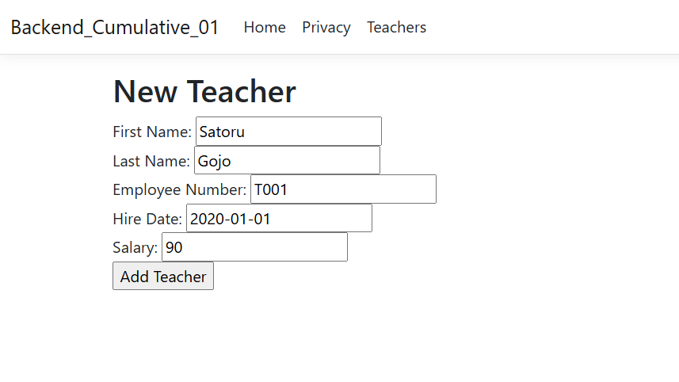

1. A web page that confirms the action to delete a Teacher

1. An API which deletes a Teacher

